Carbon Review

1. What is an organic molecule?

2. Explain why carbon is important for life.

3. Make an electron distribution diagram of carbon. It is essential that you know the answers to these

questions:

a. How many valence electrons does carbon have?

b. How many bonds can carbon form?

c. What type of bonds does it form with other elements?

4. Carbon chains form skeletons. List here the types of skeletons that can be formed.

5. What is a hydrocarbon? Name two.

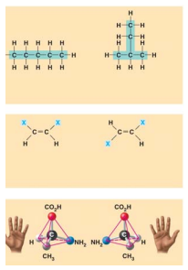6. Are hydrocarbons hydrophobic or hydrophilic?

7. What is an isomer?

8. What is a structural isomer?

9. What is an enantiomer?

10. Use this figure to identify the three types of isomers.

For each type, give a key character and an example.

11. Give one example of enantiomers that vary in their pharmacological effect.

12. These are important functional groups to know. Complete the following chart of functional groups.

|  |  |  |  |
| --- | --- | --- | --- |
| Name of group | Structure | Functional Properties | Example |
| Amino |  |  |  |
| Methyl |  |  |  |
| Carboxyl |  |  |  |
| Hydroxyl |  |  |  |
| Aldehyde |  |  |  |
| carbonyl (keto) |  |  |  |
| Sulfhydryl (thiol) |  |  |  |
| Phosphate |  |  |  |

13. You will need to master the chart and the information in it. Using the functional groups above, see if you can answer the following prompts:

a. –NH2

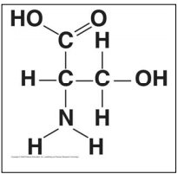b. Can form cross-links that stabilize protein structure

c. Key component of ATP

d. Can affect gene expression

e. CH3

f. Is always polar

g. Determines the two groups of sugars

h. Has acidic properties

i. –COOH

j. Acts as a base

k. Circle and identify three functional groups in the molecule shown above.